Report
Team Title: Five Stars ⭐⭐⭐⭐⭐
Project Idea : Hotel Management System
Team Members :
- Doaa Abdelsattar Farid Elwany 2401248020
- Sama Sherif Mohamed 2401241267
- Somia Ahmed Ibrahim Othman 2401242005
- Rahma Hany Mohamed 2401247261
- Abdelrahman Osama Eldesoky 2401247716

Introduction
The Hotel Management System project aims to simulate the operations of a modern hotel, managing guests, rooms, staff, bookings, and payments. The system provides a structured database that helps the hotel management team efficiently track and organize all activities.
The project includes several main tables representing key entities, with relations between tables to ensure data integrity and easy querying:
- Guests: Stores personal information of hotel visitors, including full name, social security number (SSD), email, and age. Each guest can have multiple contact phone numbers. Each guest can have a (one-to-many) relationship with Bookings.
- Guest Phones: Maintains the phone numbers associated with each guest for easy communication.
- Room Types: Defines room categories (Single, Double, Suite) along with their respective prices per night. Each Room Type can be assigned to multiple Rooms (one-to-many).
- Staff Shifts: Contains information about hotel employees, including role (Cleaner, Reception, Manager), contact details, salary, hire date, and assigned shift. Each Staff has a (one-to-one )relation with a shift.
- Rooms: Tracks room numbers, floor, current status (Available, Occupied, Cleaning), room type, and the staff member responsible for it. Each Room has a (one-to-one) relation with Booking and (one-to-many) relation with Staff.
- Bookings: Manages reservations made by guests, including check-in and check-out dates, booking date, meal plan, and booking status. Each Booking has a (one-to-one) relation with Payment.
- Payments: Records payment information for each booking, including amount, date, and payment method.
This system demonstrates relational database concepts, with interconnected tables, foreign keys, and constraints to maintain data consistency. It enables queries for reporting and analytics, such as Full Booking Details Report, Total Revenue per Room Type, Average Stay per Room Type, Upcoming Bookings, Top 5 Guests by Payment, Staff Responsibilities, Guest Phones List, Booking Meal Plans, Number of Bookings per Meal Plan, Monthly Revenue and Bookings Report.
ERD
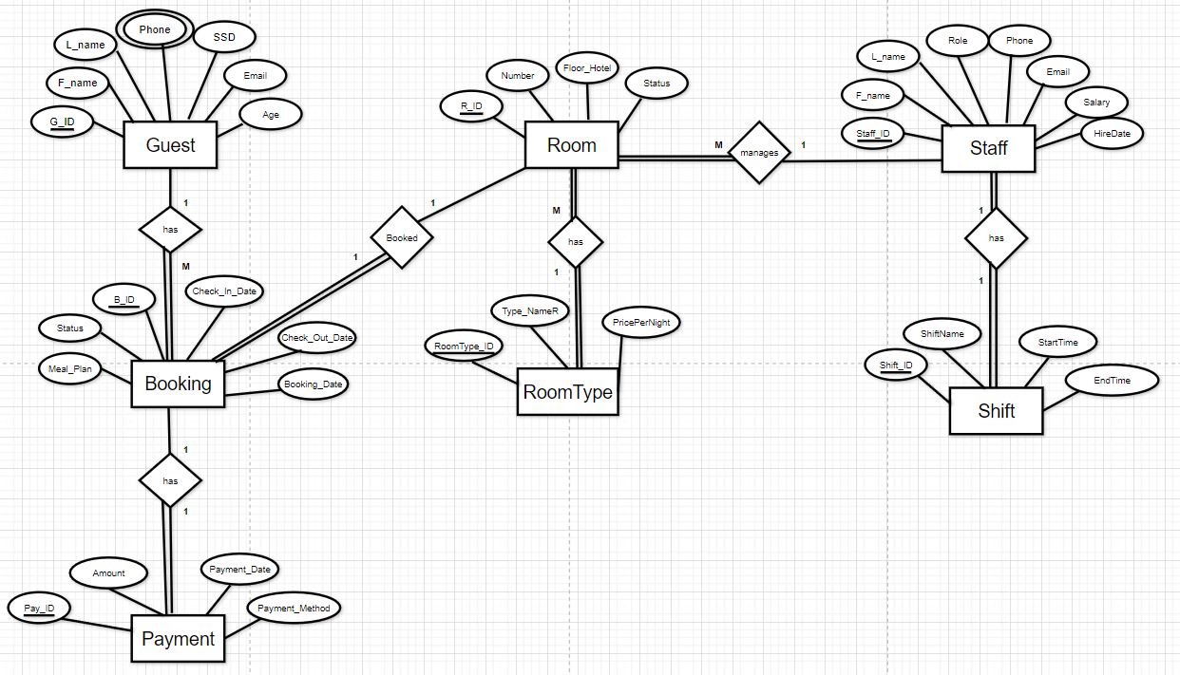

Relational Schema 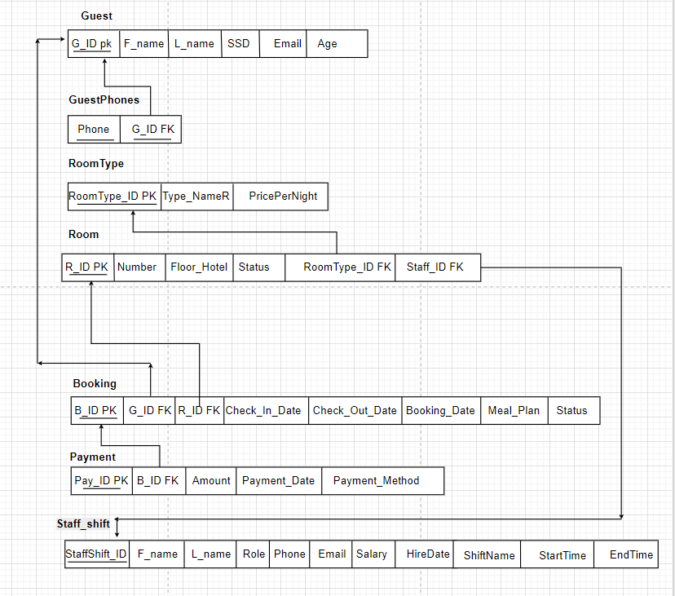

Data Dictionary
1. Guest : Stores personal information about each guest
Field Name | Data Type | Field Length | Constraint | Description
G_ID | Int | __ | Primary Key, Auto Increment | Unique ID for each guest
F_name | Varchar | 20 | Not Null | Guest first name
L_name | Varchar | 20 | Not Null | Guest last name
Email | Varchar | 50 | Null, Unique | Guest email address
SSD | Varchar | 14 | Not Null | National ID
Age | Int | __ | Null , Check (Age ≥ 16) | Age of the guest

2. GuestPhones : Stores multiple phone numbers for each guest
Field Name | Data Type | Field Length | Constraint | Description
Phone | Varchar | 20 | Not Null , Primary Key (composite with G_ID) | Guest phone number
G_ID | Int | __ | Not Null , Foreign Key → Guest(G_ID) | References the guest
3. RoomType: Represents categories of rooms (Single, Double, Suite) and their prices
Field Name | Data Type | Field Length | Constraint | Description
RoomType_ID | Int | __ | Primary Key, Auto Increment | Unique ID for room type
Type_NameR | Varchar | 30 | Not Null | Name of room type ) single , doule , suite )
PricePerNight | Decimal | )10,2( | Not Null ,  Check(PricePerNight >0 ) | Price Per Night

4. Room : Tracks rooms in the hotel including their floor, number, and status.
Field Name | Data Type | Field Length | Constraint | Description
R_ID | Int | __ | Primary Key, Auto Increment | Unique ID for each room
Number | Int | __ | Not Null , Check (Number >0) | Room number (e.g., 101, 205)
Floor_Hotel | Int | __ | Not Null , Check (Floor_Hotel >= 0) | Floor number
Status | Varchar | 20 | Not Null, Check ('Available','Occupied','Maintenance') | Current room status
RoomType_ID | Int | __ | Foreign Key → RoomType(RoomType_ID) | Type of the room
Staff_ID | Int | __ | Foreign Key → Staff_Shift(StaffShift_ID) | Staff responsible for the room

5. Booking: Represents a guest’s reservation for a room, including check-in, check-out, and meal plan.
Field Name | Data Type | Field Length | Constraint | Description
B_ID | Int | __ | Primary Key, Auto Increment | Unique ID for booking
G_ID | Int | __ | Foreign Key → Guest(G_ID), Not Null | Guest who made the booking
R_ID | Int | __ | Foreign Key → Room(R_ID), Not Null | Room being booked
Check_In_Date | Date | __ | Not Null | Check-in date
Check_Out_Date | Date | __ | Not Null | Check-out date
Booking_Date | Date | __ | Not Null | Date when booking was made
Meal_Plan | Varchar | 20 | Null | Meal plan (Breakfast, Half Board, Full Board, None )
Status | Varchar | 20 | Null | Booking Status(confirmed , Checked-in , Completed, Upcoming)

6. Payment: Stores payment details for each booking
Field Name | Data Type | Field Length | Constraint | Description
Pay_ID | Int | __ | Primary Key, Auto Increment | Unique payment ID
B_ID | Int | __ | Foreign Key → Booking(B_ID), Not Null | Booking this payment is for
Amount | Decimal | (10,2) | Not Null , check(Amount >0) | Payment amount
Payment_Date | Date | __ | Null | Date of payment
Payment_Method | Varchar | 20 | Null, Check ('Cash','Card','Online') | Payment method

7.Staff_Shift : Contains information about employees and their assigned work shifts. Each staff member works exactly one shift, so shift details are included directly in this table.

Field Name | Data Type | Field Length | Constraint | Description
StaffShift_ID | Int | __ | Primary Key, Auto Increment | Unique ID for staff & shift
F_name | Varchar | 20 | Not Null | Staff first name
L_name | Varchar | 20 | Not Null | Staff last name
Role | Varchar | 20 | Not Null | Job role (Reception, Cleaner , Manager )
Phone | Varchar | 20 | Null | Staff phone
Email | Varchar | 50 | Null , Unique | Staff email
Salary | Decimal | (10,2) | Not Null ,Check(Salary >0) | Monthly salary
HireDate | Date | __ | Null | Date of hiring
ShiftName | Varchar | 20 | Not Null | Shift name (Morning, Evening , Night)
StartTime | Time | __ | Not Null | Shift start time
EndTime | Time | __ | Not Null | Shift end time

DDL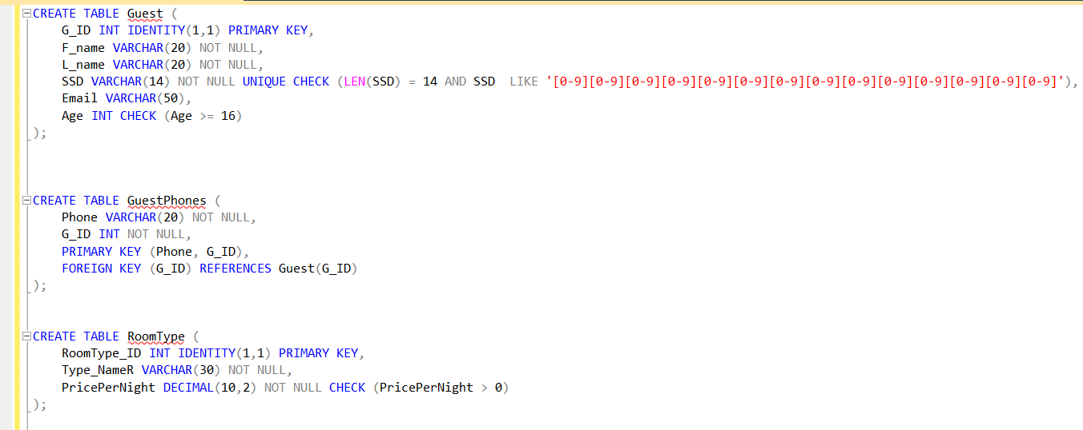
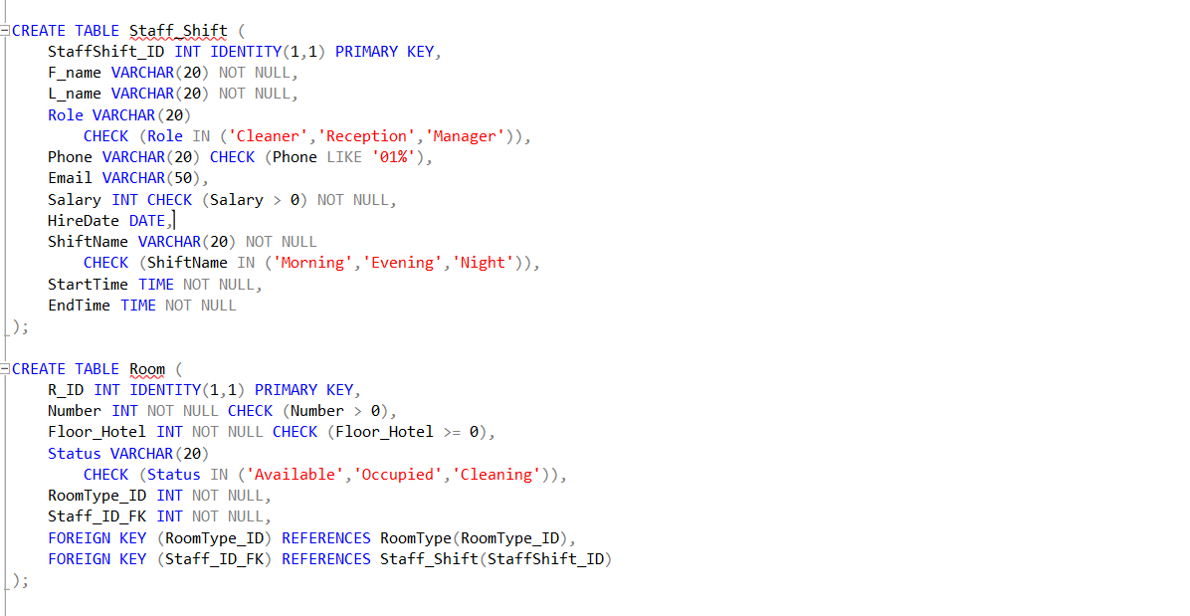

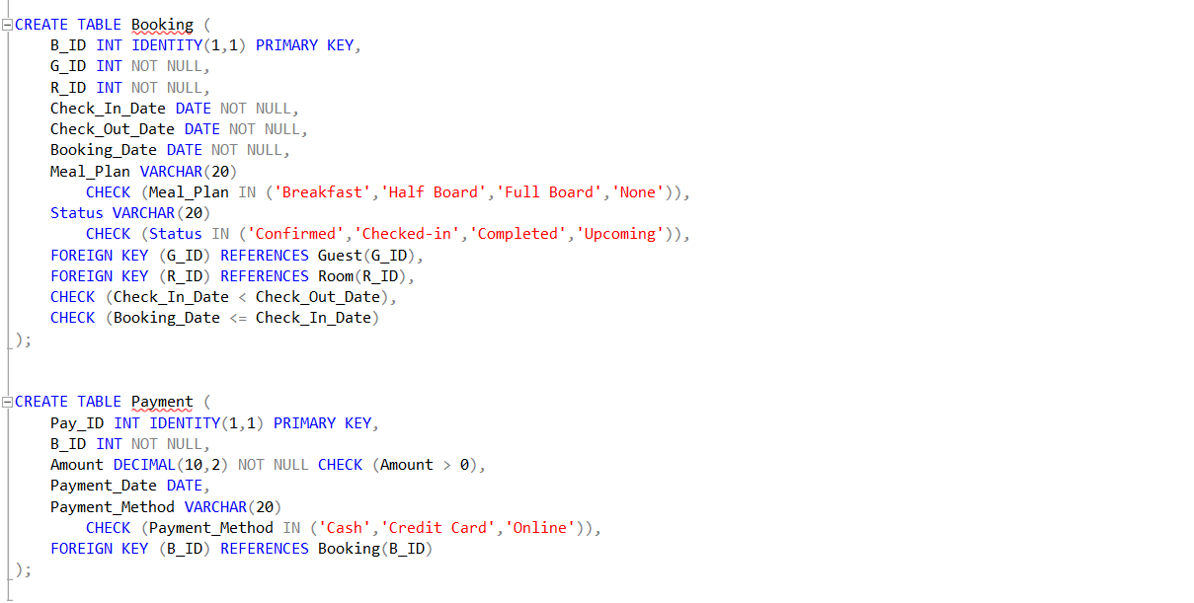
DML
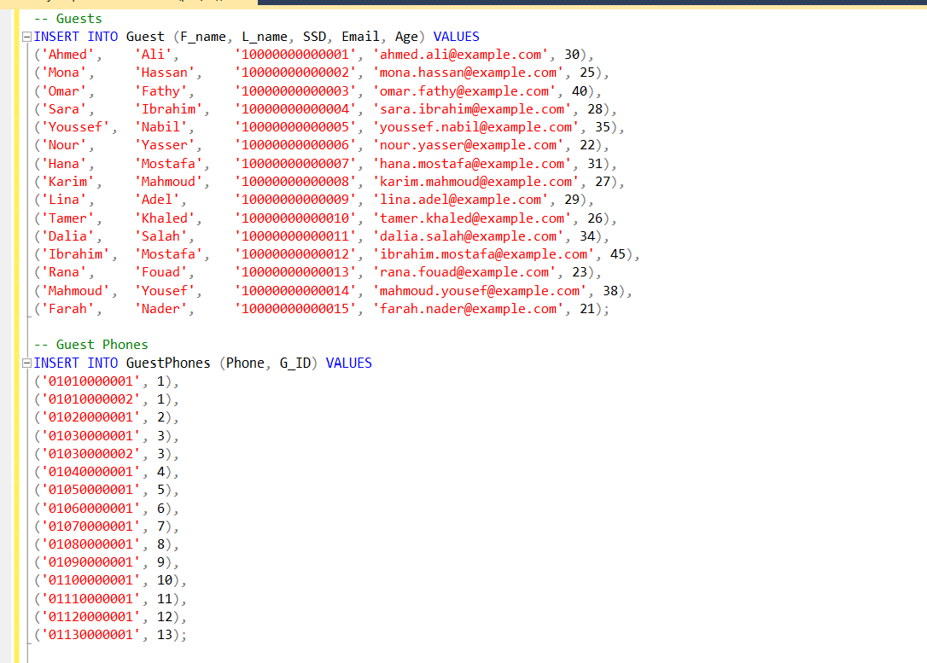
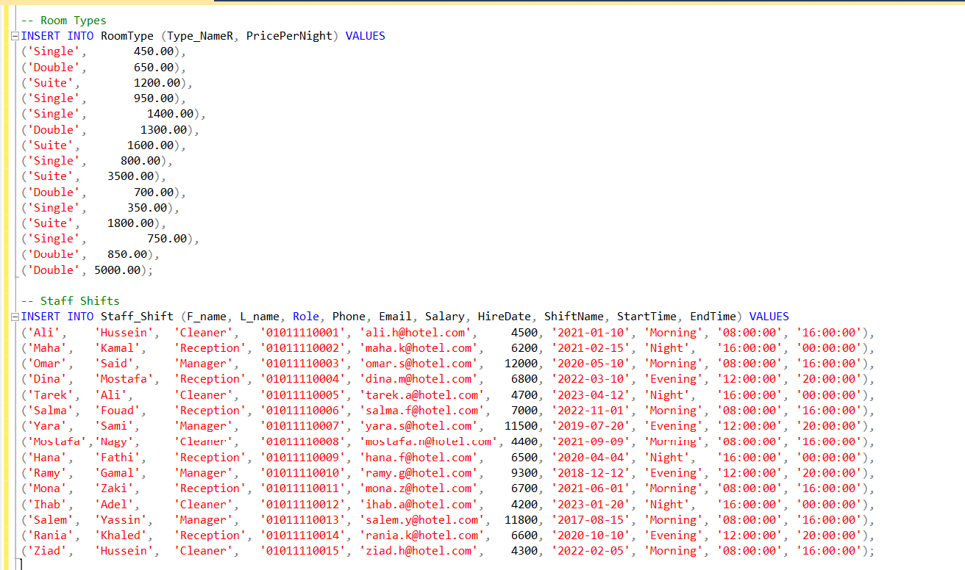
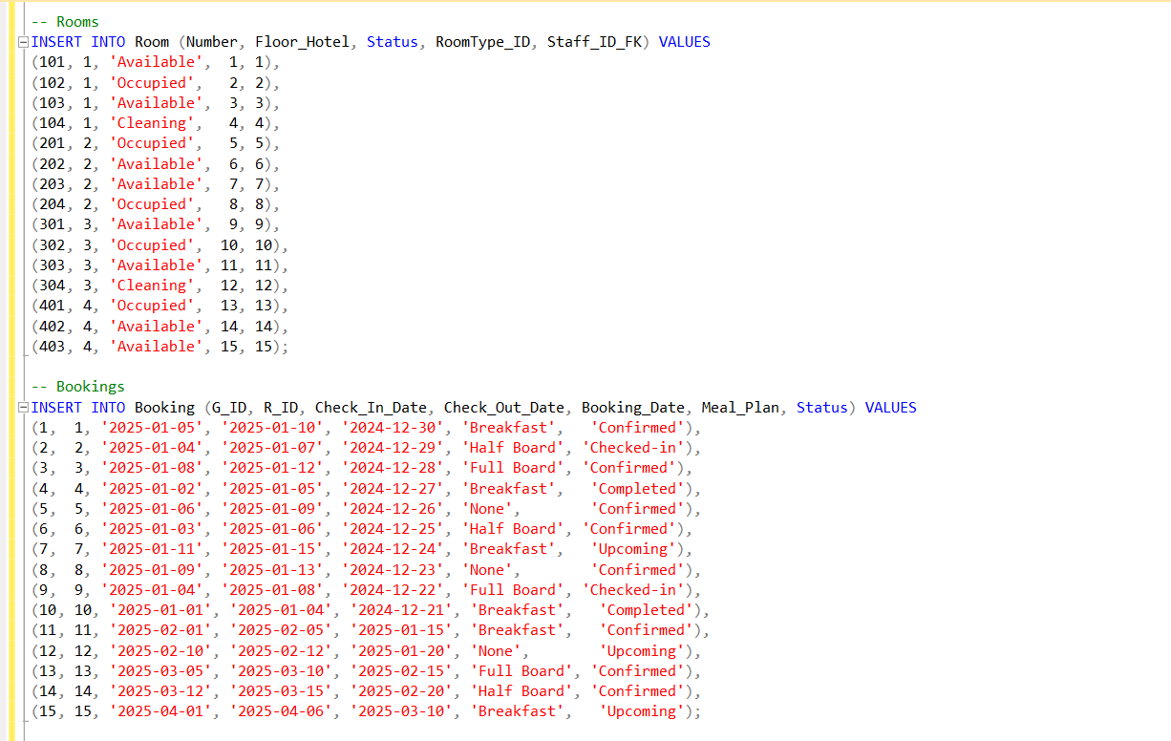
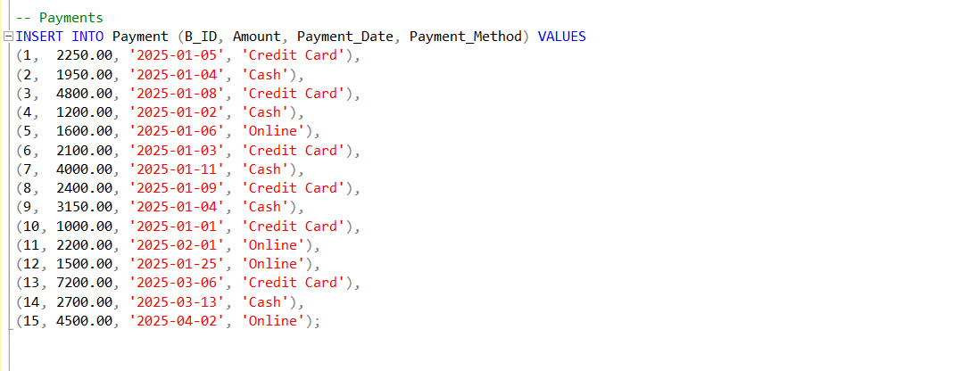

Queries & Pathway Transaction
Query 1: Full Booking Details Report
SELECT g.F_name + ' ' + g.L_name AS GuestName, r.Number AS RoomNumber,
rt.Type_NameR AS RoomType, b.Check_In_Date, b.Check_Out_Date,
DATEDIFF(DAY, b.Check_In_Date, b.Check_Out_Date) AS StayDuration,
rt.PricePerNight,
rt.PricePerNight * DATEDIFF(DAY, b.Check_In_Date, b.Check_Out_Date) AS TotalBookingAmount,
p.Payment_Method, b.Status AS BookingStatus
FROM Booking b
JOIN Guest g ON b.G_ID = g.G_ID
JOIN Room r ON b.R_ID = r.R_ID
JOIN RoomType rt ON r.RoomType_ID = rt.RoomType_ID
LEFT JOIN Payment p ON b.B_ID = p.B_ID
ORDER BY b.Check_In_Date;

send to DBMS
↓
query optimization
↓
call tables: Booking (b), Guest (g), Room (r), RoomType (rt), Payment (p)
↓
apply joins: (b.G_ID = g.G_ID), (b.R_ID = r.R_ID), (r.RoomType_ID = rt.RoomType_ID), (b.B_ID = p.B_ID)
↓
compute derived: StayDuration = DATEDIFF(DAY, Check_In_Date, Check_Out_Date),
TotalBookingAmount = PricePerNight * StayDuration
↓
collect results: GuestName, RoomNumber, RoomType, Check_In_Date, Check_Out_Date, StayDuration, PricePerNight, TotalBookingAmount, Payment_Method, BookingStatus
↓
order by Check_In_Date
↓
show results
Query 2: Total Revenue per Room Type
SELECT rt.Type_NameR AS Room_Type, SUM(p.Amount) AS Total_Revenue
FROM Payment p
JOIN Booking b ON p.B_ID = b.B_ID
JOIN Room r ON b.R_ID = r.R_ID
JOIN RoomType rt ON r.RoomType_ID = rt.RoomType_ID
GROUP BY rt.Type_NameR
ORDER BY Total_Revenue DESC;

send to DBMS
↓
query optimization
↓
call tables: Payment (p), Booking (b), Room (r), RoomType (rt)
↓
apply joins: (p.B_ID = b.B_ID), (b.R_ID = r.R_ID), (r.RoomType_ID = rt.RoomType_ID)
↓
compute derived: Total_Revenue = SUM(p.Amount)
↓
collect results: Room_Type, Total_Revenue
↓
group by Room_Type
↓
order by Total_Revenue DESC
↓
show results

Query 3: Average Stay Duration per Room Type
SELECT rt.Type_NameR AS Room_Type,
AVG(DATEDIFF(DAY, b.Check_In_Date, b.Check_Out_Date)) AS Avg_Stay_Nights
FROM Booking b
JOIN Room r ON b.R_ID = r.R_ID
JOIN RoomType rt ON r.RoomType_ID = rt.RoomType_ID
GROUP BY rt.Type_NameR
ORDER BY Avg_Stay_Nights DESC;

send to DBMS
↓
query optimization
↓
call tables: Booking (b), Room (r), RoomType (rt)
↓
apply joins: (b.R_ID = r.R_ID), (r.RoomType_ID = rt.RoomType_ID)
↓
compute derived: Avg_Stay_Nights = AVG(DATEDIFF(DAY, Check_In_Date, Check_Out_Date))
↓
collect results: Room_Type, Avg_Stay_Nights
↓
group by Room_Type
↓
order by Avg_Stay_Nights DESC
↓
show results

Query 4: Upcoming Bookings List
SELECT b.B_ID, g.F_name, g.L_name, r.Number AS RoomNumber, b.Check_In_Date
FROM Booking b
JOIN Guest g ON b.G_ID = g.G_ID
JOIN Room r ON b.R_ID = r.R_ID
WHERE b.Status = 'Upcoming';
send to DBMS
↓
query optimization
↓
call tables: Booking (b), Guest (g), Room (r)
↓
apply joins: (b.G_ID = g.G_ID), (b.R_ID = r.R_ID)
↓
filter: b.Status = 'Upcoming'
↓
collect results: B_ID, F_name, L_name, RoomNumber, Check_In_Date
↓
show results

Query 5: Top 5 Guests by Total Payments
SELECT TOP 5
g.F_name + ' ' + g.L_name AS GuestName,
SUM(p.Amount) AS TotalPaid
FROM Payment p
JOIN Booking b ON p.B_ID = b.B_ID
JOIN Guest g ON b.G_ID = g.G_ID
GROUP BY g.F_name, g.L_name
ORDER BY TotalPaid DESC;

send to DBMS
↓
query optimization
↓
call tables: Payment (p), Booking (b), Guest (g)
↓
apply joins: (p.B_ID = b.B_ID), (b.G_ID = g.G_ID)
↓
compute derived: TotalPaid = SUM(p.Amount)
↓
collect results: GuestName, TotalPaid
↓
group by GuestName
↓
order by TotalPaid DESC
↓
limit top 5
↓
show results

Query 6: Staff Responsibilities Report
SELECT s.F_name + ' ' + s.L_name AS StaffName, s.Role, s.ShiftName, COUNT(r.R_ID) AS RoomsResponsible
FROM Staff_Shift s
LEFT JOIN Room r ON r.Staff_ID_FK = s.StaffShift_ID
GROUP BY s.F_name, s.L_name, s.Role, s.ShiftName
ORDER BY RoomsResponsible DESC;

send to DBMS
↓
query optimization
↓
call tables: Staff_Shift (s), Room (r)
↓
apply joins: LEFT JOIN (r.Staff_ID_FK = s.StaffShift_ID)
↓
compute derived: RoomsResponsible = COUNT(r.R_ID)
↓
collect results: StaffName, Role, ShiftName, RoomsResponsible
↓
group by StaffName, Role, ShiftName
↓
order by RoomsResponsible DESC
↓
show results

Query 7: Guest Phone Directory
SELECT g.F_name + ' ' + g.L_name AS GuestName, gp.Phone
FROM Guest g
LEFT JOIN GuestPhones gp ON g.G_ID = gp.G_ID
ORDER BY g.F_name, g.L_name;

send to DBMS
↓
query optimization
↓
call tables: Guest (g), GuestPhones (gp)
↓
apply joins: LEFT JOIN (gp.G_ID = g.G_ID)
↓
collect results: GuestName, Phone
↓
order by GuestName
↓
show results

Query 8: Booking Meal Plan Summary
SELECT b.B_ID AS BookingID, g.F_name + ' ' + g.L_name AS GuestName, r.Number AS RoomNumber, b.Meal_Plan
FROM Booking b
JOIN Guest g ON b.G_ID = g.G_ID
JOIN Room r ON b.R_ID = r.R_ID
ORDER BY b.B_ID;

send to DBMS
↓
query optimization
↓
call tables: Booking (b), Guest (g), Room (r)
↓
apply joins: (b.G_ID = g.G_ID), (b.R_ID = r.R_ID)
↓
collect results: BookingID, GuestName, RoomNumber, Meal_Plan
↓
order by BookingID
↓
show results

Query 9: Booking Count per Meal Plan
SELECT
Meal_Plan,
COUNT(*) AS NumberOfBookings
FROM Booking
GROUP BY Meal_Plan;

send to DBMS
↓
query optimization
↓
call table: Booking
↓
compute derived: NumberOfBookings = COUNT(*)
↓
collect results: Meal_Plan, NumberOfBookings
↓
group by Meal_Plan
↓
show results

Query 10: Monthly Bookings and Revenue Analysis
SELECT YEAR(b.Check_In_Date) AS Year, MONTH(b.Check_In_Date) AS Month,
COUNT(b.B_ID) AS NumberOfBookings,
SUM(rt.PricePerNight * DATEDIFF(DAY, b.Check_In_Date, b.Check_Out_Date)) AS TotalRevenue
FROM Booking b
JOIN Room r ON b.R_ID = r.R_ID
JOIN RoomType rt ON r.RoomType_ID = rt.RoomType_ID
GROUP BY YEAR(b.Check_In_Date), MONTH(b.Check_In_Date)
ORDER BY Year, Month;

send to DBMS
↓
query optimization
↓
call tables: Booking (b), Room (r), RoomType (rt)
↓
apply joins: (b.R_ID = r.R_ID), (r.RoomType_ID = rt.RoomType_ID)
↓
compute derived: NumberOfBookings = COUNT(B_ID),
TotalRevenue = SUM(PricePerNight * DATEDIFF(DAY, Check_In_Date, Check_Out_Date))
↓
collect results: Year, Month, NumberOfBookings, TotalRevenue
↓
group by Year, Month
↓
order by Year, Month
↓
show results

GUI
